**Cheap Shop Catalog Store**

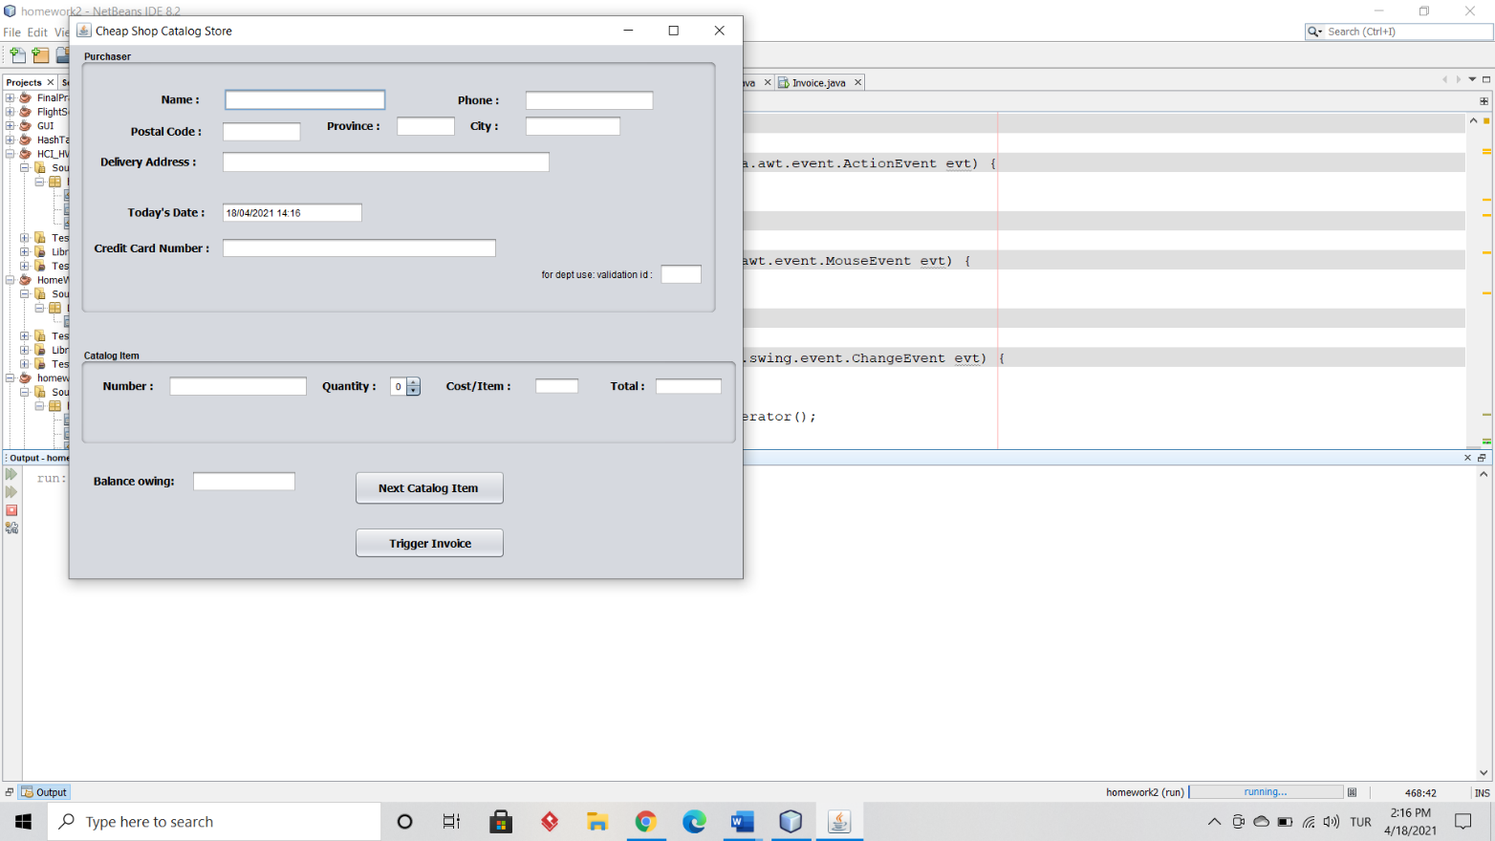The CheapShopStore is a store where customers can shop. It offer 10 products numbered 100-109. Java was used as the programming language. This class extends Jframe, which dispalys the welcome GUI screen when it runs. By default, the current date and time is set, however the customer can change it if needed(Fig 1).

Fig 1

Default screen

If the customer wants to buy a product, he/she first fill their information on the Purchaser screen and then choose a product from the Catalog Item screen. The customer should enter the correct product number to the number textfield. When the customer picks the quantity needed, the cost per item and the total price is displayed on the screen. The total price is calculated by cost * quantity in quantitySpinnerStateChanged(javax.swing.event.ChangeEvent evt) method. If the customer wants to order more items, he/she can click on the Next Catalog Item button which directs him/her to another screen. This screen is a GUI screen created by the CatalogItem Jframe class. The customer then follows the same procedure as the first order. After the customer finishes his/her order, he/she can click on the Trigger Invoice button that creates an invoice with the orders description and total price in an another screen. This screen is a GUI screen created by the Invoice jframe class.

For the CheapShopStore class 14 labels, 13 textFields , 2 buttons , 2 panels and 1 spinner was used. For the CatalogItem class 5 labels, 4 textFields , 2 buttons, 1 panel and 1 spinner was used. For the Invoice class 2 labels , 1 textField and 1 textArea was used. All the three jframe classes have a linkedlist attribute called *orderList* that stores the orders made by each customer. The CheapShopStore and the CatalogItem classes have an extra linkedlist attribute called *items* that stores the items/products provided by the store.The items were created inside the constructor. Two more classes were created the Item class and the Order class. The Item class has the product *number* as a String type and the product *price* with type double. The Order class has 3 attributes, the *ordernumber* which is essentially the product number as a string type, the *total* price as a string type and the *quantity* of the order with type int.

**Example 1**

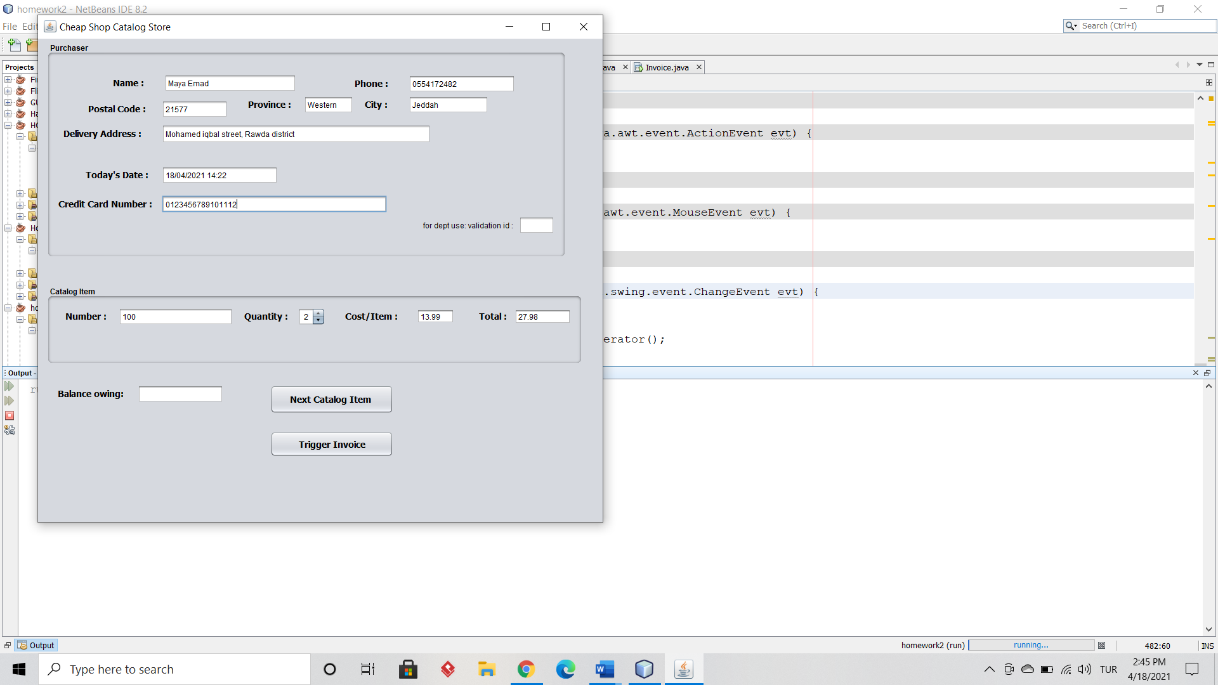

Fig 2

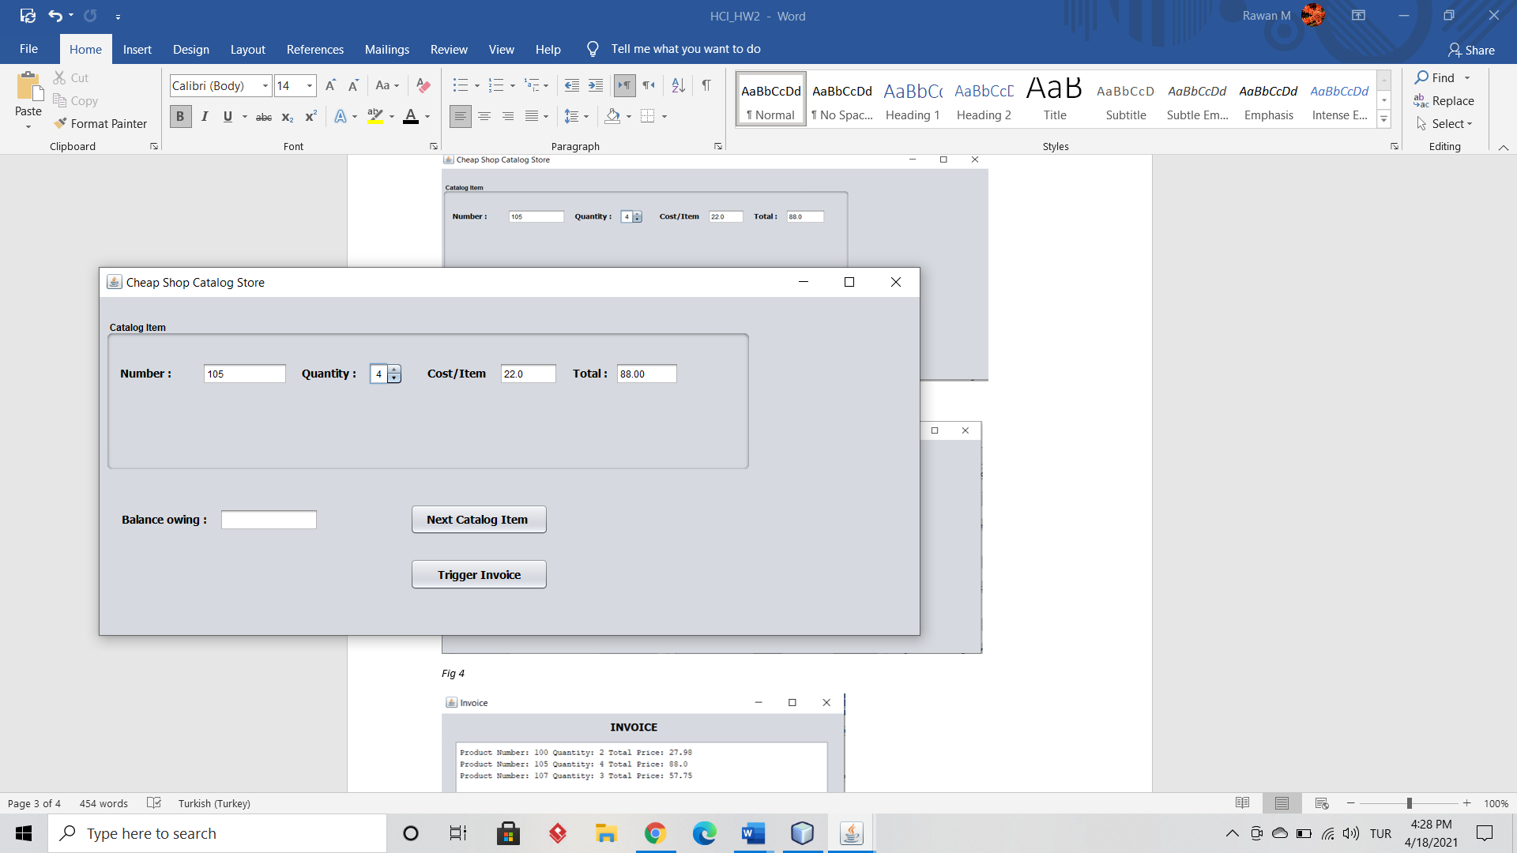

Fig 3

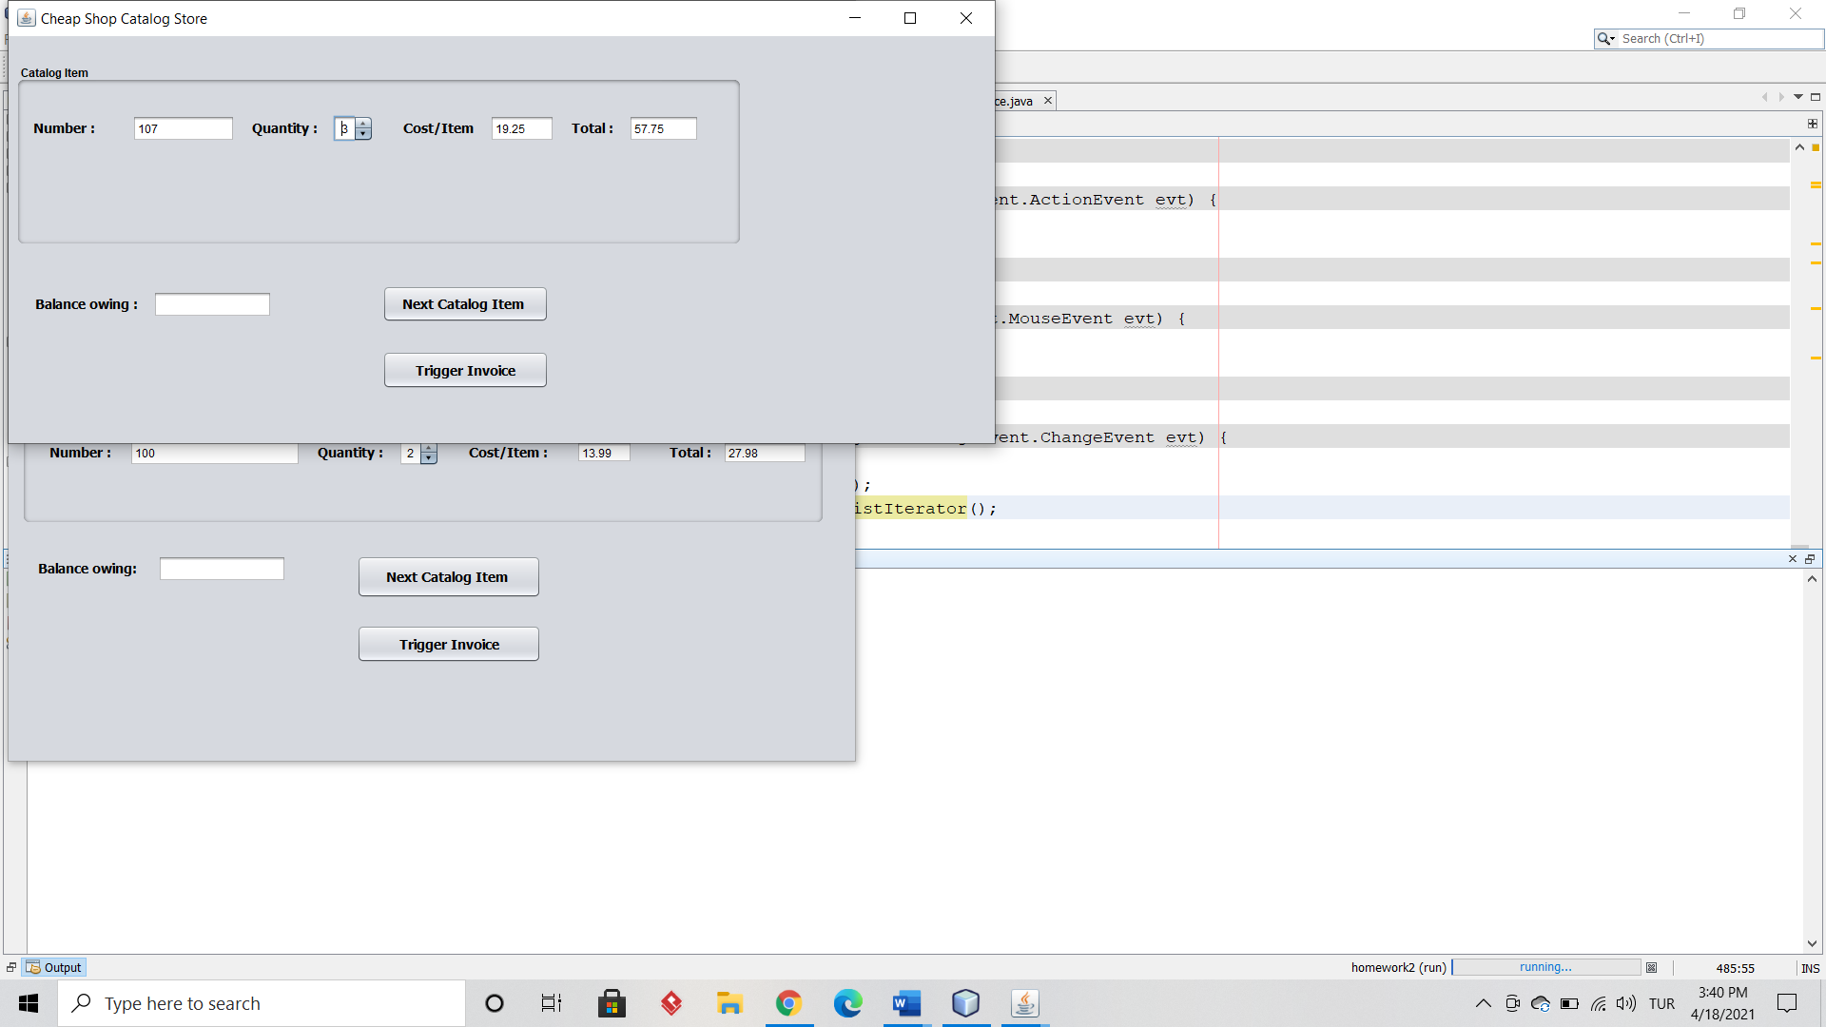

Fig 4

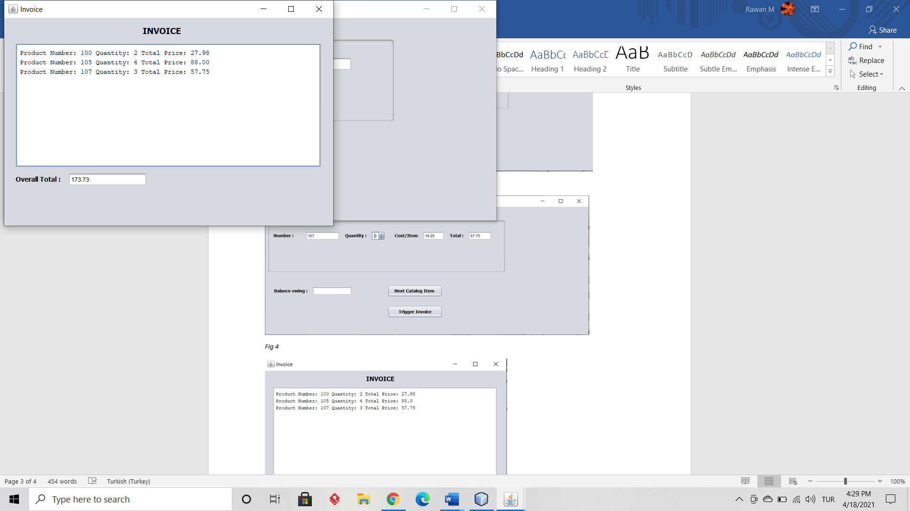

Fig 5

Customer Maya Emad entered her personal information and ordered 3 different products. She ordered two quantites from product number 100 for 2*13.99 = 27.98 dollars (Fig 2), then by clicking on Next Catalog Item button she ordered four quantites from product number 105 for 4*22 = 88.00 dollars (Fig 3 ), and then again by clicking on the Next Catalog Item she ordered three quantites from product number 107 (Fig 4) for 3*19.25 = 57.75 dollars. Finally she requested an invoice by clicking on Trigger Invoice button and her overall total was 27.98 + 88 + 57.75 = 173.73 dollars (Fig 5).

**Example 2**

Customer Dave Smith entered his personal information and ordered six quantites from product number 108 for 6*34.45 = 206.70 dollars (Fig 6). He requested an invoice by clicking on Trigger Invoice button and his overall total was 206.70 dollars (Fig 7).

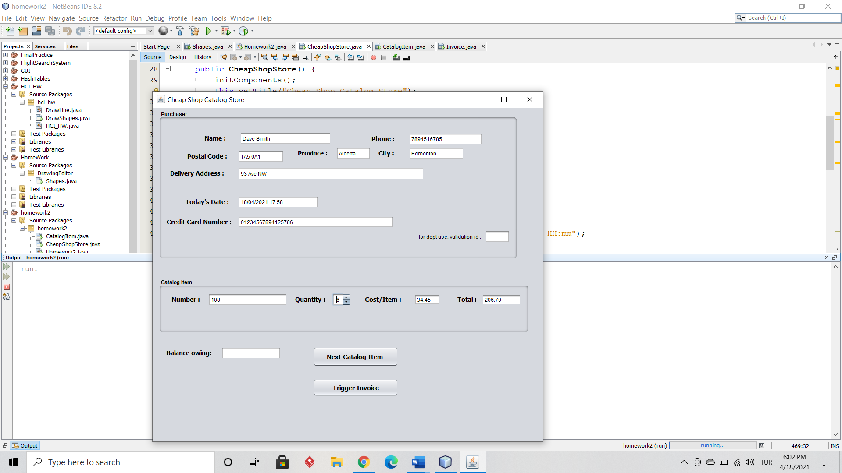

Fig 6

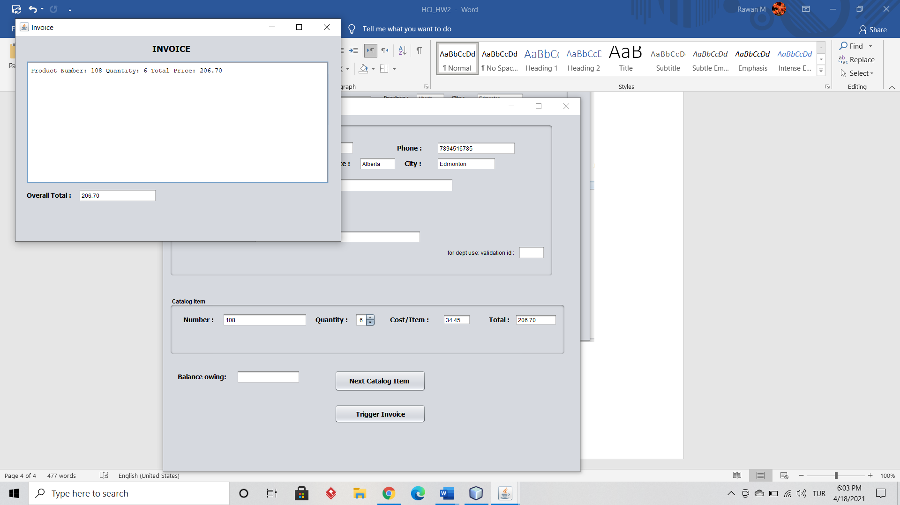

Fig 7